
MINNESOTA STATE UNIVERSITY, MANKATO
DEPARTMENT OF COMPUTER INFORMATION SCIENCE
COMPUTER SCIENCE PROGRAM

FINAL HANDOVER DOCUMENT
Intuilize Customer Segmentation Team
5/3/2025

Clients:
Mahesh Iyer
Data Scientist | Intuilize

Nelson Valderrama
CEO | Intuilize

Project members:
Andy Hjulberg
Team Lead

Shashank Reddy
Machine Learning Lead

Sai Keertana Lakku
Data Scientist Lead

Graham Wilkins
Documentation/Machine Learning Research Lead

Faculty coach:
Ryne Leytem

Table of Contents
1. Introduction 3
2. Our Client and Their Goals 3
2.1 Our Client 3
2.1 Their Goals 3
3. Information Received from Client 3
3.1 Dataset 3
3.2 Previous Iterations 3
4. Timeline 4
4.1 First Quarter 4
4.2 Second Quarter 4
4.3 Third Quarter 4
4.4 Fourth Quarter 5
5. Project Artifacts 6

1. Introduction
The goal of this document is to ensure that any continuations of this project have a smooth transition. This document gives an overview of the information and resources included in the final project package. This document will provide pointers to all the various artifacts that were developed during the project.

2. Our Client and Their Goals

2.1 Our Client
Our client was Intuilize Co., which is a leading machine learning firm that specializes in offering changing solutions in pricing for wholesalers based off the insights they gather from their machine learning.

2.1 Their Goals
The team was tasked with creating a machine learning model that could segment customers into tiers based on the sales data that was provided. After segmentation, Intuilize wanted the team to create a prediction model that would predict the movement of customers between tiers. A more detailed description of the client’s deliverables, and a plan of action is laid out in the “Requirements Analysis Document”.

3. Information Received from Client

3.1 Dataset
The client provided a comma separated csv file that listed transactions from customers from December 2021 to January 2025. For simplicity the team used 2022-2024, as it was complete full years of data. This is located in the client resources folder of the handover package.

3.2 Previous Iterations
The client also shared both previous iterations (Intuilize CS and Intuilize QB) of this project. These handovers included all documentation and code that was delivered to the client in their semesters. The team created a document titled “Intuilize Previous Progress” that gives a brief project summary of these previous iterations and describes what information and ideas the team used from the previous iterations’ handover document. These project folders are both included in the client resources folder of the handover package.

4. Timeline
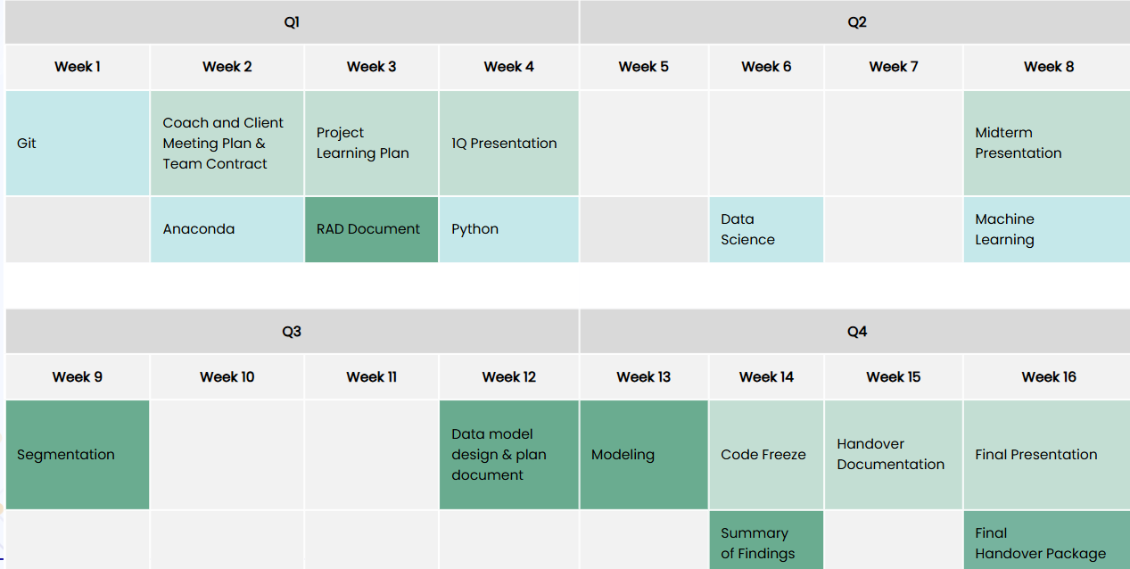

4.1 First Quarter
In the first quarter the team began learning on Git, Anaconda and Python. This allowed the team to get a repository and environment set up for the project. During this time, the team created a coach meeting plan, team contract, and a project learning plan. The Requirements Analysis Document (RAD) was also created and sent to the client (the document was edited throughout the semester). A bulk of the data analysis and feature selection was also developed in this time.

4.2 Second Quarter
In the second quarter the team completed learning on data analysis and machine learning early in the quarter. The team then finished data analysis and had features selected for the models. The team then began work on Segmentation models, primarily using k-means, hierarchal, and fuzzy clustering. The team also began work on the Data Model Design and Plan Document, although only the segmentation section could be completed.

4.3 Third Quarter
In the third quarter the team completed Segmentation and began working on prediction models (Modeling), primarily focusing on Markov Chain and a monthly aggregate approach. The team then updated the Data Model Design and Plan Document to include prediction models.

4.4 Fourth Quarter
In the fourth quarter the team completed and fine-tuned all prediction and segmentation models. The team also began working on documentation and cleaning code. The team also created an automated feature selection system this time. Towards the end of the semester the team completed the Summary of Findings document. Finally, the team delivered the Final Handover Package to the client.

5. Project Artifacts
- Handover Document
This is the current document.

- Team Contract
This document outlines the roles and responsibilities of each team member and is located in the school deliverables folder.

- Coach Meeting Plan
This document outlines the team’s plan for meeting with the faculty coach and is located in the school deliverables folder.

- Project Learning Plan
This document outlines the team’s plan for learning the required tools and resources for the project. It is located in the school deliverables folder.

- Client Presentations
The team gave weekly client presentations in client meetings. Those presentations are all listed by date in the weekly client presentation folder.

- Q1 Presentation
The teams Q1 presentation slides are located in the presentations folder.

- Midterm Presentation
The teams midterm presentation slides are located in the presentations folder.

- Final Presentation
The teams final presentation slides are located in the presentations folder.

- Requirements Analysis Document (RAD)
This document outlines the requirements for the project and the team’s plan of action for completing deliverables. It is located in the handover documentation folder.

- Previous Progress Document
This document outlines how the team used the previous iteration’s handover documents to assist our development. It is located in the handover documentation folder.

- Data Model Design and Plan Document
This document outlines the different segmentation and prediction models the team considered and tested. It is located in the handover documentation folder.

- Summary of Findings Document
This document details the performance of the segmentation and prediction models and describes areas for improvement. It is located in the handover documentation folder.

- Summary of Findings PowerPoint and Presentation
This is the teams presentation on the summary of findings from this project. It includes slides and a video recording of the presentation. These are both located in the main handover package folder.

- Segmentation
This includes the team’s k-means, hierarchal, and fuzzy c-means models that were used to segment the customers into tiers. It is located in the segmentation folder of the codebase.

- Prediction
This includes the team’s Markov-chain and monthly aggregate prediction approaches. It is located in the prediction folder of the codebase.

- ReadMe
This includes technical details and set up instructions for the environment. It is located in the codebase.

- Intuilize CS S24
This is a zip folder that includes the handover package from the previous customer segmentation team. It is located in the Intuilize CS S24 zip folder in the client resources folder.

- Intuilize QB F24
This is a zip folder that includes the handover package from the quantity break team. It is located in the Intuilize QB F24 zip folder in the client resources folder.

- Dataset
The client provided dataset is located in the client resources folder.

